Brick Landing Master Association
Property Settlement/Closing and Security Credentialing Process

Purpose:
This document provides general guidance related to the management of funds collected at closing for property settlements within Brick Landing Plantation. It also outlines the steps to initiate Security Credentialing, including pool passes, car stickers, and bricklanding.org website setup.
In accordance with the BLP Articles of Incorporation, all property sales within Brick Landing Plantation will include a Security and Accounting Change Fee as part of the closing process.
The Security and Accounting Change Fee is $300 and supports sub-association settlement accounting fees of $100 as well as BLPMA $200 fees associated with security credentialing.
The Process:
Step | Description | Additional Information
1 | Sub-association Treasurer receives a request from the Closing Attorney for sub-association dues and/or settlement fees | The request could first come to the sub-association President, then to sub-association Treasurer
2 | Sub-association Treasurer completes the Property Settlement Statement Form (Attachment A) and returns it to the Closing Attorney and copies the BLPMA Treasurer | The form should include:  - Quarterly/monthly dues amount  - Property dues account status
3 | Sub-association Treasurer also provides the Information for new Brick Landing Plantation property owners (Attachment B) to the Closing Attorney to provide to the buyer | The Information for new Brick Landing Plantation property owners explains how to start the Security Credentialing Process
4 | Closing Attorney provides sub-association Treasurer with a $300 Security and Accounting Change Fee | Sub-association Treasurer  - Creates $300 Accounts Receivable entry for Sub-association.  - Creates $200 Accounts Payable entry for BLPMA.
5 | Sub-association Treasurer completes New Homeowner Security Fee Form (Attachment C) and provides the form and $200 to the BLPMA Treasurer | BLPMA Treasurer creates $200 Accounts Receivable entry for BLPMA for Security Credentialing, including creation and distribution of car stickers and pool passes
Part 2 – Closing Date occurs
6 | If the buyer completed the New Resident Form, CAMS releases credentials | Credentials are created per the information on the New Resident Form created by the new resident
7 | Buyer receives an email with account information and credential pickup location
8 | Web Master approves account registration request for bricklanding.org and updates the contact information on bricklanding.org.
Property Settlement Statement Form

Brick Landing Sub-Association:

Property information
Street address:
Lot No:
Parcel No:

Seller/Buyer Information
Seller's Name:
Buyer's Name:
Buyer's Email:
Buyer's Phone Number:
Buyer's Residence Address if not in BL:

Scheduled Closing Date*:
(* if date is postponed, send email to: secretary@bricklanding.org)

Contacts
Closing Attorney Name:
Email:

Sub-Association Treasurer Contact:
Name:
Email:

Dues information:
Dues amount:
Dues payment frequency:
Dues account status for property address:

The closing attorney should:
- Provide the $300 Security and Accounting Change Fee, made out the sub-association, and a copy of this form to the sub-association treasurer listed above.
- Provide the Information for new Brick Landing Plantation property owners to the buyer to enable them access to Brick Landing Plantation properties and receive community information.

Attachment A

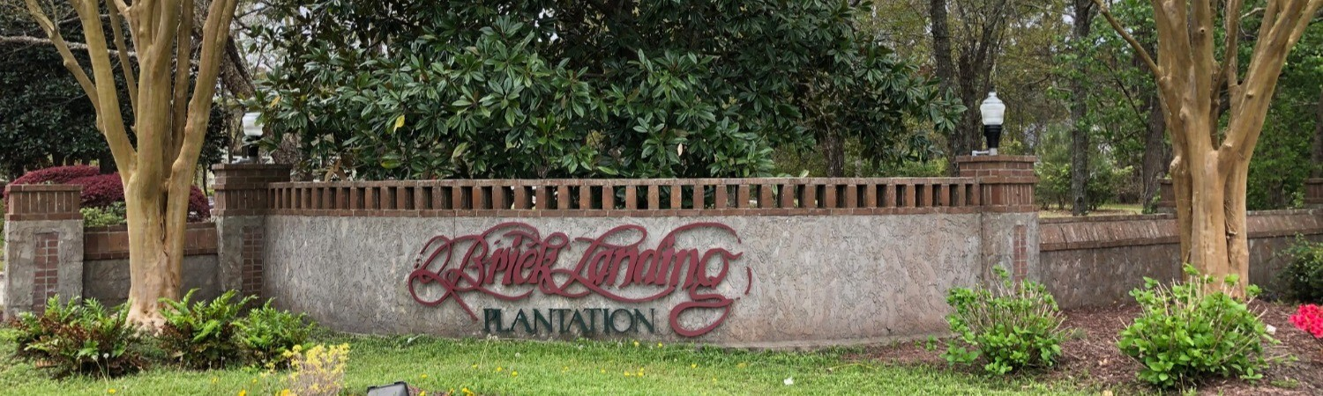
Information for new Brick Landing Plantation property owners
Welcome! Here’s information you need to get access to our gates, pool and website – bricklanding.org.
- Your first step is to be sure the Admin/Security fee of $300 was included in your HUD closing statement.

- Next, go to Bricklanding.org > Security (Sticker and Access Cards) > New Residents – Start here!
There you will find a link to the BL Security Registration Form, which you need to complete.
You may fill out the form before you close on the property, but we will not provide the credentials to you until you are the legal owner of the home. If you close on a lot, you will have credentials as soon as you are the legal owner of the lot.
If your closing date changes, please email secretary@bricklanding.org.
- Register for access to the Brick Landing Website (bricklanding.org)
Go to Login or Register in the right-hand corner of bricklanding.org
Click on Register and fill out your household information
Completing the BL Security Registration Form and registering for the Brick Landing Website will ensure you have everything you need as a resident of Brick Landing.
If you have questions, send an email to secretary@bricklanding.org and someone will get back to you as soon as possible.
Thank you for your cooperation. We are so glad you've chosen our great neighborhood as your next home -- you're going to like it here!

Attachment B
New Homeowner Security Fee Form
Created due to a Property Settlement

Subject: For Deposit to BLPMA GL 4216

Property information

Brick Landing Sub-Association:
Street address:
Lot No:
Parcel No:

Sub-Association Treasurer provides this form and a check for $200 to the BLPMA Treasurer.

BLPMA Treasurer will scan and email the completed form to CAMS representative. Additionally, the completed form and checks will be mailed to the following address for processing:
BLPMA c/o CAMS
4911 Long Beach Rd. SE Unit 1
Southport, NC 28461

Sub-Association Treasurer: ____________________________________ Date: ____________

BLPMA Treasurer: ___________________________________________ Date: _____________

Attachment C

Revision | Revision Date | Details of Changes Made
1 | 3/3/25
2 | 3/16/25 | Process flow – removed inconsistent process labels; updates to contact emails; provide some after closing instructions for Buyer to obtain security credentials
3 | 7/3/2025 | Re-formatted the document
4 | 9/25/2025 | Updated the Property Settlement Statement Form to include instructions for the closing attorney
5 | 9/30/25 | Edited the forms so they can be filled out online.
6 | 10/16/2025 | Updated CAMS address
7 | 10/20/25 | Removed fillable fields

